Career Pathways
Showing not telling how to enter construction apprenticeships

https://www.apprenticeshipsrock.com/career-pathways
Begin with a visualized apprenticeship pathway map, perhaps using this as a starter/guide:
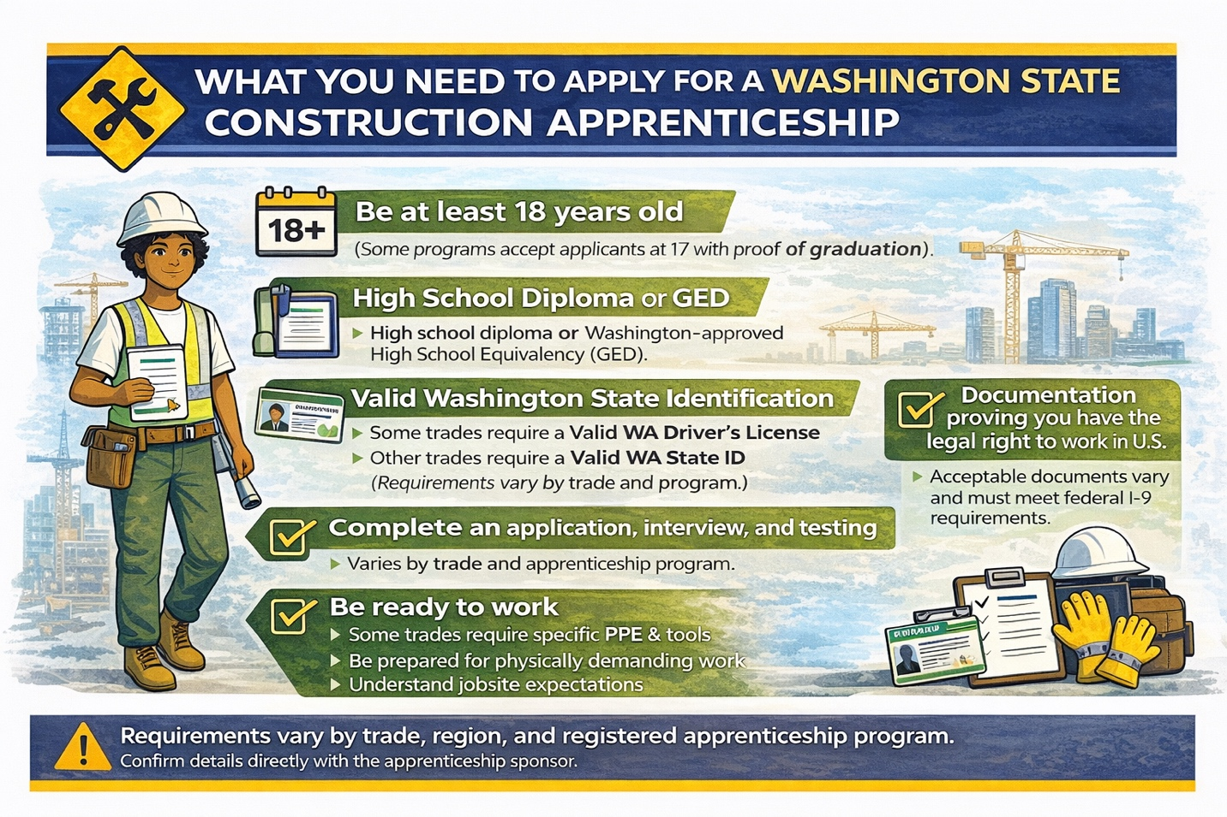
Existing languange on the page needs to be pared down significantly. Cut all sections until the second half of the “READY TO START YOUR PATHWAY?” in yellow at the bottom (see note below). Above that section, use the CCI step-by-step language, adjusted a bit:
Step-by-Step Guide to Starting Your Apprenticeship:
- Explore Construction Trades: Identify the trades that interest you. Whether it’s videos, reading through this site or talking to people in construction, think about what you might like to do every day. (e.g., carpentry, electrical, plumbing, heavy equipment operation, roofing, etc.).
- Know Yourself and Define Your Goals: Spend time writing down all of your skills, abilities, knowledge, professional skills, and what you love to do for work – and what you don’t. Determine if apprenticeship is right for you by talking over your list with a friend, family member, teacher, or career counselor, thinking about what you want to achieve through an apprenticeship.
- Research Apprenticeships: Use resources like the Apprenticeships Rock contacts page to find programs and more information.
- Check Requirements: Programs often require a high school diploma or GED, reliable transportation, and a minimum age (usually 18). Check each apprenticeship’s website for details as requirement vary between programs and trades.
- Apply to Programs: Submit complete applications early, prepare thoroughly for interviews, and demonstrate enthusiasm and commitment.
Next Steps: Start exploring today to launch your rewarding construction career! Utilize Apprenticeships Rock to research and explore what construction career pathways through apprenticeship are the best fit for you!

After this section, keep the second half of the last section, in yellow, that says YOUR CONSTRUCTION CAREER STARTS TODAY with the four links below (EXPLORE TRADES CAREERS, LEARN ABOUT PREP PROGRAMS, EXPLORE OFFICE CAREERS, CONTACT US FOR GUIDANCE). On that last link, change CONTACT US FOR GUIDANCE to CONTACTS.

